**CROSSBROWSER**

package testngpack;

import org.openqa.selenium.WebDriver;

import org.openqa.selenium.chrome.ChromeDriver;

import org.testng.annotations.Test;

import org.openqa.selenium.firefox.FirefoxDriver;

public class crossbrowser {

@Test

void open_chrome() {

System.setProperty("webdriver.chrome.driver","C:/Users/hai/Downloads/chromedriver_win32/chromedriver.exe");

WebDriver driver = new ChromeDriver();

driver.get("https://www.google.com/");

}

@Test

void open_firefox() {

System.setProperty("webdriver.gecko.driver","C:/Users/hai/Downloads/geckodriver_win32/geckodriver.exe");

WebDriver driver = new FirefoxDriver();

driver.get("https://www.firefox.com/");

}}

OUTPUT:

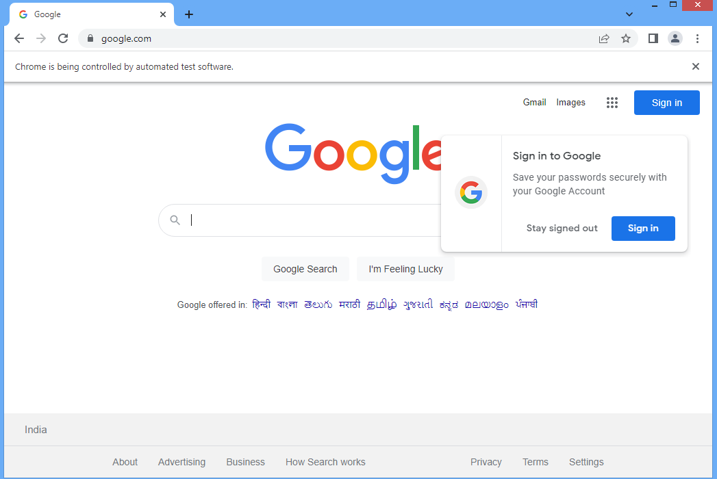

**PARALLEL OPEN BROWSER**

**import** org.openqa.selenium.WebDriver;

**import** org.openqa.selenium.chrome.ChromeDriver;

**import** org.openqa.selenium.chrome.ChromeOptions;

**import** org.testng.annotations.Test;

**public** **class** parallel {

@Test

**public** **void** opnapp() {

System.*setProperty*("webdriver.chrome.driver","C:/Users/hai/Downloads/chromedriver_win32/chromedriver.exe");

ChromeOptions options = **new** ChromeOptions();

options.addArguments("--remote-allow-origins=*");

WebDriver driver = **new** ChromeDriver();

driver.get("https://www.google.com/");

}

@Test

**public** **void** opnappl() {

System.*setProperty*("webdriver.chrome.driver","C:/Users/hai/Downloads/chromedriver_win32/chromedriver.exe");

ChromeOptions options = **new** ChromeOptions();

options.addArguments("--remote-allow-origins=*");

WebDriver driver = **new** ChromeDriver();

driver.get("https://www.yahoo.com/");

}

}

OUTPUT:

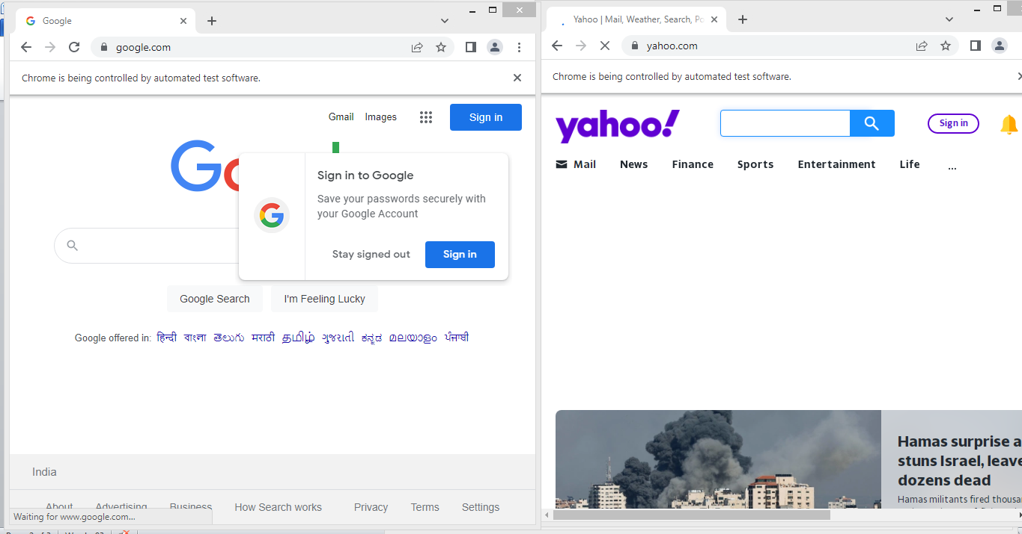

**PRIORITY**

**import** org.testng.annotations.Test;

**public** **class** priority {

@Test(priority=1)

**public** **void** one() {

System.***out***.println("Method One");

}

@Test(priority=2)

**public** **void** two() {

System.***out***.println("Method Two");

}

@Test(priority=3)

**public** **void** three() {

System.***out***.println("Method Three");

}

}

OUTPUT:

Method One

Method Two

Method Three

**PASSING PARAMETERS USING XML FILE**

**import** org.openqa.selenium.By;

**import** org.testng.annotations.Test;

**import** org.openqa.selenium.WebDriver;

**import** org.openqa.selenium.chrome.ChromeDriver;

**import** org.testng.annotations.Parameters;

**public** **class** testngdemo {

WebDriver driver;

@Test(priority=0)

@Parameters("browser")

**public** **void** initialisation(String value) {

**if**(value.equals("chrome")) {

System.*setProperty*("webdriver.chrome.driver","C:/Users/hai/Downloads/chromedriver_win32/chromedriver.exe");

driver = **new** ChromeDriver();

driver.get("https://adactinhotelapp.com");

}}

@Test(priority =1)

@Parameters({"username","password"})

**public** **void** login(String val1,String val2) {

driver.findElement(By.*id*("username")).sendKeys(val1);

driver.findElement(By.*id*("password")).sendKeys(val2);

driver.findElement(By.*id*("login")).click();

}

}

**XMLCODE**

<?xml version="1.0" encoding="UTF-8"?>

<!DOCTYPE suite SYSTEM "https://testng.org/testng-1.0.dtd">

<suite name="Suite">

<test thread-count="5" name="Test">

<parameter name="browser" value="chrome"></parameter>

<parameter name="username" value="KulotthunganR"></parameter>

<parameter name="password" value="9W9GAN"></parameter>

<classes>

<class name="testngpack.testngdemo"/>

</classes>

</test> <!-- Test -->

</suite> <!-- Suite -->

OUTPUT:

